# **For ASP:**

|  |  |
| --- | --- |
| **Activity** | **Details** |
| Login | Straightforward, just for the JFF members |
| Register | Register JFF members |
| Main Activity  (Index) | Will display a complete list of added schools and include buttons for expanding on the details of the entries as well as editing and printing. |
| Details Page | Contains all the information about the selected school, will return information in the manner of the image attached or similar. The details page will also contain a button for printing the report but the report must be printed in the manner of the attached image.  Details page will also allow the option to view the graphical representation of the collected information, as displayed in the attached.  *NOTE: Find image after the table detailing the mobile layout. |
| Edit Page | Will return the collected information on the community and allow it to be edited. |

# **For Mobile:**

|  |  |
| --- | --- |
| **Activity** | **Details** |
| Login | Straightforward, just for the JFF members |
| Register | Register JFF members |
| Main Activity  (Index) | Will display a list of recently added schools and include buttons for creating a new entry for the list. Items from list can be selected for quick edits. |
| School Registration | Details for the school that JFF is presenting at. Must capture: **Date, School Name, Community Name, Names of JFF Attendants, Principal’s name, Comments**. |
| School Details | Contains the information collected so far including the values for the students according to each category. Manual value input.  Details will be collected offline and then uploaded to the cloud storage. |
| School Details Edit. | Similar to School Details but will allow editing. |

# **Attachments:**

## ASP Details Page Printing:

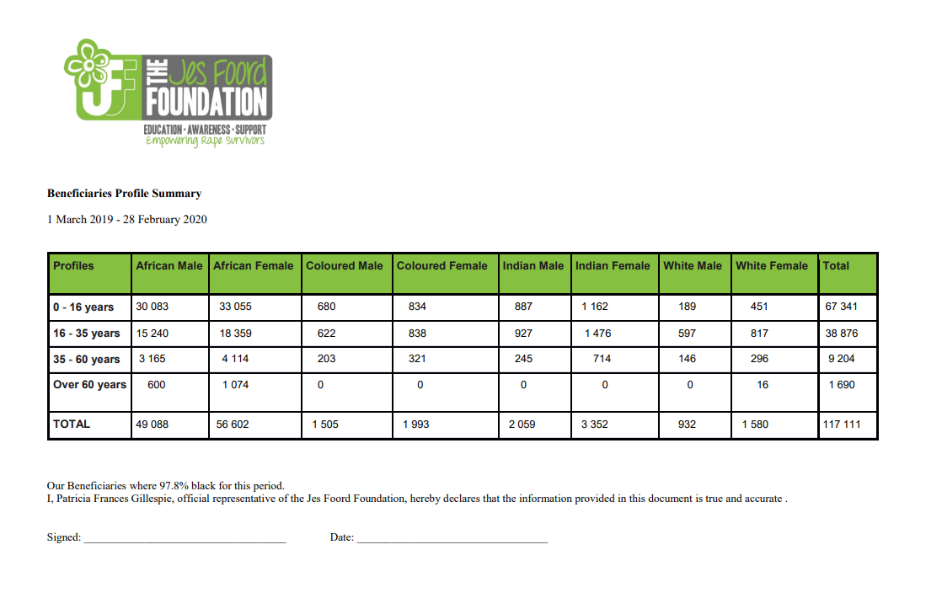

## ASP Graphical Representation:

